Chapter 4: Proposed System Architecture
4.1 Overview
The proposed congestion-control system is designed as a feedback-based congestion-control framework that combines Explicit Congestion Notification (ECN) information with Bandwidth-Delay Product (BDP) estimation to dynamically regulate the TCP congestion window (CWND).
The proposed implementation consists of six functional modules:
- Traffic Generator
- VBR Generator
- ECN Monitor
- ECN Controller
- BDP Monitor
- BDP Controller
These six modules operate within a shared network environment containing a bottleneck link and an ECN-enabled queue. The network configuration is not considered an additional software module; it provides the environment through which congestion information is generated and fed back to the controller.
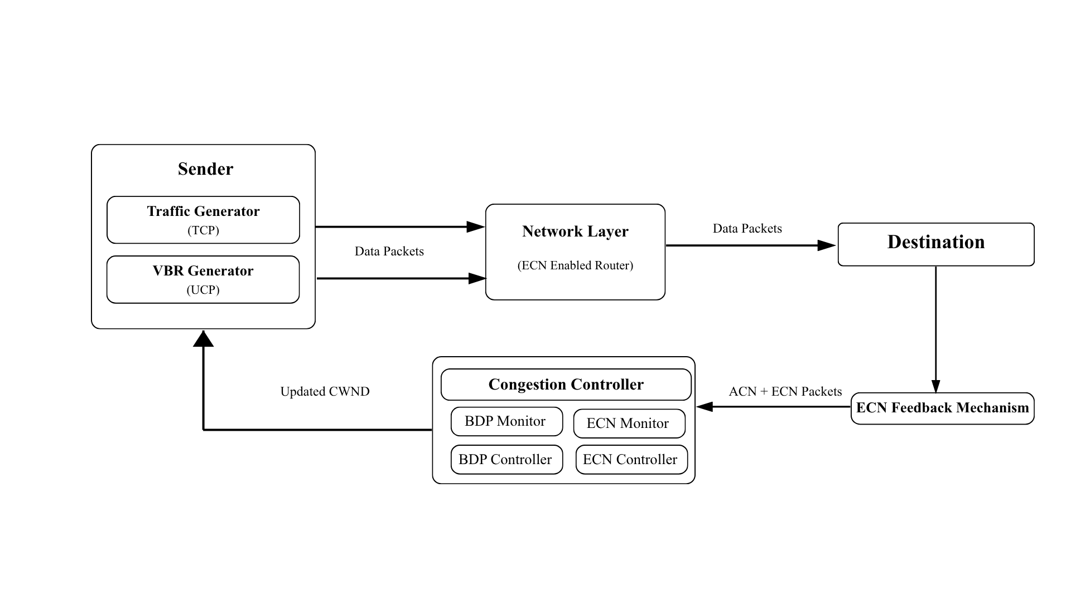
The Traffic Generator generates TCP traffic, while the VBR Generator introduces variable-rate background traffic. The resulting traffic passes through the shared bottleneck, where congestion can produce ECN feedback. The ECN Monitor collects the congestion-marking information, and the ECN Controller uses this information to determine an ECN-based CWND adjustment. In parallel, the BDP Monitor obtains RTT and bandwidth information and estimates the BDP. The BDP Controller then applies the BDP constraint to obtain the final congestion-window value.
The overall feedback mechanism can be represented as:

Fig. 4.1.1 High Level Architecture Diagram
4.2 Network Topology
Network Topology of the proposed Congestion-Control System:

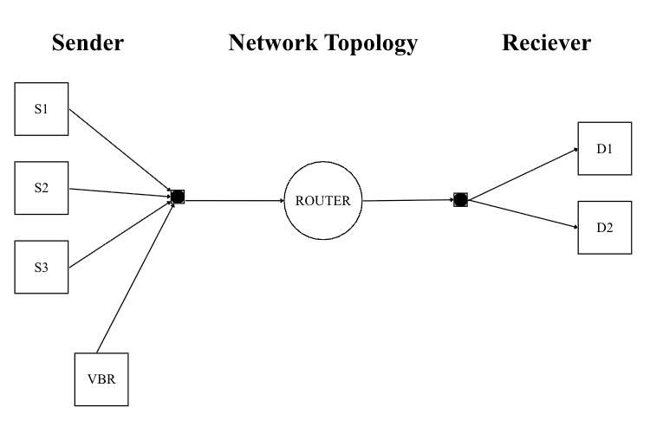
Fig 4.2.1 Network Topology of the proposed Congestion-Control System
4.3 Traffic Generator Module
The Traffic Generator module is responsible for generating the primary TCP traffic used to evaluate the proposed congestion-control mechanism.
The module configures the TCP sender and receiver and determines the amount of application data to be transmitted based on the configured packet count and packet size. The implementation calculates the total application data as:
$$D=N_{p}×S_{p}$$
where:
- DD = total application data in bytes
- Np = number of application packets
- Sp= packet size in bytes.

Algorithm 1: TCP Traffic Generation
Input: Packet count Np, Packet size Sp , Source node, Destination node Simulation time T.
Output: TCP traffic
Begin
1. Initialize TCP sender and receiver.
2. Read packet count Np and packet size Sp.
3. Calculate total data:
D = Np × Sp
4. Configure TCP sender.
5. Configure TCP receiver.
6. Assign source and destination addresses.
7. Start TCP transmission.
8. Continue transmission until D bytes are
transmitted or simulation time expires.
9. Record transmission statistics.
End
4.4 VBR Generator Module
The VBR Generator provides variable-rate background traffic to create a dynamic network load. This prevents the congestion environment from remaining completely static and allows the proposed controller to operate under changing traffic conditions.
The VBR traffic rate varies between a minimum and maximum configured rate.
The instantaneous rate can be represented as:
$$R_{VBR}\left(t\right)∈\left[R_{min},R_{max}\right]$$
where:
- R_{VBR}(t) = VBR transmission rate at time tt
- R_{min}= minimum VBR rate
- R_{max}= maximum VBR rate.
The VBR generator is installed separately from the TCP traffic generator and uses UDP-based traffic in the simulation.
Algorithm 2: VBR Traffic Generation
Input: Minimum rate Rmin, Maximum rate Rmax, Packet size Sp, Simulation time T
Output: Variable-rate background traffic
Begin
1. Initialize VBR sender and receiver.
2. Configure UDP transport.
3. Set minimum transmission rate Rmin.
4. Set maximum transmission rate Rmax.
5. Select/update the current VBR rate.
6. Generate packets according to the current rate.
7. Transmit packets through the shared network.
8. Repeat rate generation/update until simulation ends.
End.
4.5 ECN Monitor Module
The ECN Monitor is responsible for collecting congestion information from the network. It maintains the number of packets observed and the number of packets marked with ECN.
The module maintains the following parameters:
- Total packets
- ECN-marked packets
- ECN ratio
- ECN acknowledgement count
- Last ECN acknowledgement time
The implementation connects the queue's Enqueue and Mark trace sources to the ECN Monitor.
Mathematical Formulation
The cumulative ECN ratio is:
$$E=\frac{M}{P}$$
where:
- E = ECN ratio
- M = number of ECN-marked packets
- P = total number of observed packets.
The ECN percentage is:
$$E_{\backslash \%}=E×100$$
Algorithm 3: ECN Monitoring
Input: Packet enqueue events, ECN marking events, ECN acknowledgement events
Output: ECN ratio E
Begin
1. Initialize total packet counter P = 0.
2. Initialize marked packet counter M = 0.
3. Initialize ECN ACK counter.
4. When a packet enters the queue:
P = P + 1
5. When a packet is ECN marked:
M = M + 1
6. Calculate:
E = M / P
7. When an ECN ACK is received:
Increment ECN ACK counter.
8. Record the latest ECN ACK time.
9. Provide E to the ECN Controller.
End.
4.6 ECN Controller Module
The ECN Controller is the primary congestion-response component of the V3 system. It uses the ECN ratio obtained from the ECN Monitor to determine how strongly the congestion window should be adjusted.
The controller uses the configurable parameter α\alpha to control the sensitivity of CWND reduction to the observed ECN ratio.
The core equation implemented by the controller is:
$$CWND_{new}=CWND_{old}\left(1-αE\right)$$
where:
- CWND_{old}= previous congestion window
- CWND_{new}= ECN-adjusted congestion window
- α = ECN response parameter
- E = ECN ratio.
Algorithm 4: ECN-Based CWND Adaptation
Input: Previous CWND, ECN ratio E, Alpha α
Output: ECN-adjusted CWND
Begin
1. Obtain the current CWND.
2. Obtain the current ECN ratio E.
3. Read the controller parameter α.
4. Calculate the congestion reduction factor:
F = α × E
5. Calculate the new CWND:
CWND_{new} = CWND_{old} × (1 - F)
6. Store the calculated CWND.
7. Pass the result to the BDP Controller.
End.
4.7 BDP Monitor Module
The BDP Monitor estimates the capacity of the network path using the measured RTT and the configured bottleneck bandwidth.
The Bandwidth-Delay Product represents the amount of data that can theoretically be in flight while fully utilizing the available bottleneck bandwidth.

The basic BDP equation used by the implementation is:
$$BDP = B ×RTT$$
When bandwidth is represented in bits per second, the BDP in bytes is:
$$BDP_{bytes}=\frac{B_{bps}×RTT}{8}$$
The equivalent BDP in packets is:
$$BDP_{packets}=\frac{BDP_{bytes}}{S_{p}}$$
Algorithm 5: BDP Estimation
Input: Bottleneck bandwidth B, Measured RTT, Packet size Sp
Output: BDP in bytes and packets
Begin
1. Obtain current RTT.
2. Obtain bottleneck bandwidth B.
3. Convert bandwidth from bits/s to bytes/s.
4. Calculate:
BDP_{bytes} = (B × RTT) / 8
5. Calculate:
BDP_{packets} = BDPbytes / Sp
6. Store BDP values.
7. Provide BDP to the BDP Controller.
End.
4.8 BDP Controller Module
The BDP Controller provides the capacity constraint for the congestion window calculated by the ECN Controller.
The ECN Controller first produces an ECN-based CWND. The BDP Controller then compares this value with the estimated BDP and selects the smaller value.
The final CWND is therefore:
$$CWND_{final}=\min\left(CWND_{formula},BDP\right)$$
where:
- CWND_{formula}= CWND calculated using ECN feedback
- BDP = estimated network capacity.
Combining this with the ECN equation gives:
$$\boxed{CWND_{final}=\min\left[CWND_{old}\left(1-αE\right),BDP\right]}$$
Algorithm 6: BDP-Based CWND Constraint
Input: ECN-derived CWND, Estimated BDP
Output: Final CWND
Begin
1. Receive CWNDformula from ECN Controller.
2. Obtain current BDP.
3. Compare CWNDformula and BDP.
4. Select the smaller value:
CWNDfinal = min(CWNDformula, BDP)
5. Apply CWNDfinal to the TCP connection.
6. Record the CWND update.
End.
4.9 Complete V3 Control Algorithm
The six modules operate together as a single closed-loop mechanism.
Algorithm 7: Proposed V3 Congestion-Control Algorithm
Input: TCP traffic parameters, VBR traffic parameters, Bottleneck bandwidth B,Packet size Sp
Output: Dynamically adapted CWND
Begin
1. Initialize the Traffic Generator.
2. Initialize the VBR Generator.
3. Start TCP and VBR traffic.
4. Transmit traffic through the shared bottleneck.
5. Monitor packet enqueue events.
6. Monitor ECN marking events.
7. ECN Monitor calculates ECN ratio E.
8. Obtain RTT from the network.
9. BDP Monitor calculates:
BDP = B × RTT
10. ECN Controller calculates:
CWNDformula = CWNDold × (1 - αE)
11. BDP Controller calculates:
CWNDfinal = min(CWNDformula, BDP)
12. Apply CWNDfinal to the TCP sender.
13. Continue transmission using the updated CWND.
14. Repeat the monitoring and control process whenever new feedback is received.
15. Stop when the simulation time expires.
16. Record performance metrics.
End.

